How To Develop Obedience

Discover the true meaning of OBEDIENCE


I. What is OBEDIENCE?
vs. Willfulness
OBEDIENCE is
Receiving instruction, correction, provision, and protection through the Biblical jurisdictions of parents, civil authorities, church leaders, and employers.

The meaning of obedience:
Obedience is wise submission to the will of those whom God has placed over us. True obedience is an attitude more than an action. It does not involve carrying out commands that would require us to violate the higher law of God.
The primary Hebrew word for obedience is shama, which means „to listen intelligently; to be attentive; to respond to a call; to consent.” Obedience is more than mere compliance, but it is not slavish subjection or blind submission.
Obedience is based on the motivation that God works through structures of authority and that every person must give an account to God for every decision he makes.
In the Bible, God uses the unbroken horse and the stubborn mule as examples of wilfulness: „Be ye not as the horse, or as the mule, which have no understanding: whose mouth must be held in with bit and bridle, lest they come near unto thee” (Psalm 32:9).
Obedience implies a painful breaking of the will, for even Jesus, „Though he were a Son, yet learned he obedience by the things which he suffered” (Hebrews 5:8).

II. How does God command OBEDIENCE?

1. Be obedient to God.

„. . . We ought to obey God rather than men” (Acts 5:29).

2. Be obedient to your parents.
„Children, obey your parents in the Lord: for this is right. Honour thy father and mother; which is the first commandment with promise; That it may be well with thee, and thou mayest live long on the earth” (Ephesians 6:1-3).

3. Be obedient to your conscience.
„Wherefore ye must needs be subject, not only for wrath, but also for conscience sake” (Romans 13:5).

4. Be obedient to your church elders.
„Obey them that have the rule over you, and submit yourselves: for they watch for your souls, as they that must give account, that they may do it with joy, and not with grief: for that is unprofitable for you” (Hebrews l3:l7).

5. Be obedient to your civil authorities.
„Put them in mind to he subject to principalities and powers, to obey magistrates, to be ready to every good work” (Titus 3:1).

6. Be obedient to your employer.
„Servants, obey in all things your masters according to the flesh; not with eye-service, as men pleasers; but in singleness of heart, fearing God” (Colossians 3:22).

III. How did Jesus demonstrate OBEDIENCE?

1. He obeyed God.
Jesus did nothing of His own will but did only His Heavenly Father’s will in order to fulfill Scripture. (See John 5:30.)

2. He obeyed His parents.
At the age of twelve, Jesus wanted to continue in the Temple, but He obeyed His parents and grew in wisdom. (See Luke 2:51-52.)

3. He obeyed His conscience.
The ultimate example of Christ’s obedience was His humbling of Himself and dying on the cross for our sin. (See Philippians 2:8.)

4. He obeyed His elders.
In dealing with ungodly elders, Jesus would often explain and obey the higher law of God’s Word. (See Matthew 12:10-14.)

5. He obeyed His rulers.
Jesus said to Pilate, „... Thou couldest have no power at all against me, except it were given thee from above. ...” (See John 19:11.)

6. He obeyed His employers.
By being employed by His (earthly) father in the family carpentry business, Jesus was certainly obedient to the instructions of His father. (See Mark 6:3.)
„And Jesus increased in wisdom and stature, and in favour with God and man” (Luke 2:52).

IV. Which members of the body must be controlled for OBEDIENCE?
Jesus singled out the eye and the hand as members of the body that need to obey God’s will. The importance of bringing these members under control is emphasized by the severe discipline which Jesus recommended. Just as these disciplines are unthinkable, so the transgression of these members should be unthinkable.
„And if thy right eye offend thee, pluck it out, and cast it from thee: for it is profitable for thee that one of thy members should perish, and not that thy whole body should be cast into hell. And if thy right hand offend thee, cut it off, and cast it from thee: for it is profitable for thee that one of thy members should perish, and not that thy whole body should be cast into hell” (Matthew 5:29-30).

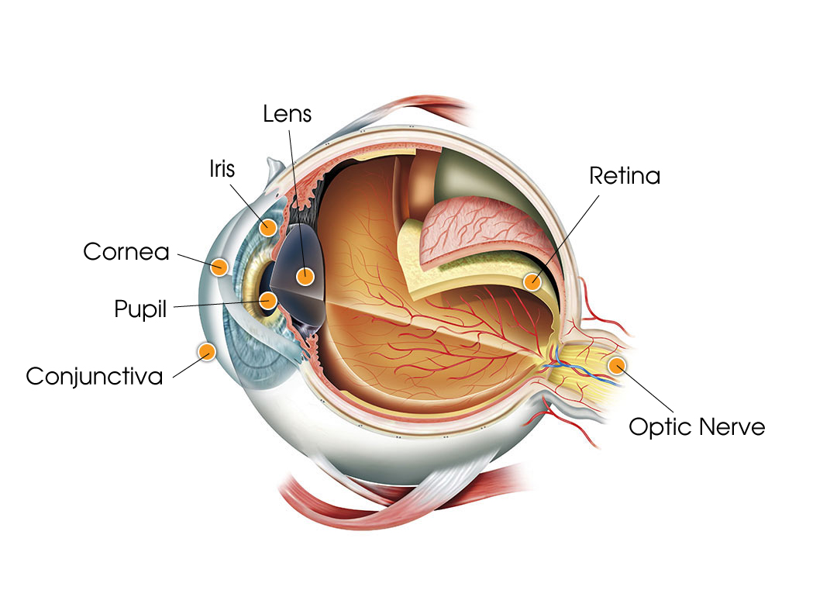
THE RIGHT EYE
For most people, the right eye is the dominant eye. It initiates the point of focus, while the other eye adds dimension and perspective. The retina of the eye receives light and converts it into chemical energy. This energy activates nerves that conduct the messages out of the eye into the higher regions of the brain. What we see affects our thoughts, attitudes, and actions. Losing the right eye, therefore, would be a severe handicap to vision.


THE RIGHT HAND
For most people, the right hand is dominant and therefore initiates actions. We greet people with the right hand, and soldiers salute with the right hand. The tactile senses in the hand send messages to the brain, and the brain sends messages to the hand. The hand is typified as the initiator of work, evil deeds, and good deeds. Jesus said, “... When thou doest alms, let not thy left hand know what thy right hand doeth” (Matthew 6:3).

V. When in history did the eye and the hand initiate DISOBEDIENCE?
The very first incident of disobedience in human history was initiated by the eye and the hand.
„And when the woman saw that the tree was good for food, and that it was pleasant to the eyes, and a tree to be desired to make one wise, she took of the fruit thereof, and did eat, and gave also unto her husband with her; and he did eat” (Genesis 3:6).
In this account, the eye initiated the transgression, and the hand carried it out. Among the consequences was the beginning of sorrows for the eye and the need for increased labor for the hand. (Read Genesis 3)
King David was a man after God’s own heart, yet one night his eyes saw Bathsheba while she was bathing on the rooftop. He sent a message by his hand to bring her to his chambers, and there he committed the horrible act of adultery.
In an attempt to cover up his sin, David arranged for the death of Bathsheba’s husband and then married Bathsheba. This heinous crime only compounded the judgments of God upon David and his family. (Read II Samuel 11-12.)
When King Saul looked at the flocks and herds of the Amalekites, whom he had just conquered, he gave direction to his soldiers to spare the best of the sheep and the best of the oxen.
This command was in direct disobedience to God’s command. When the prophet Samuel asked Saul why he had disobeyed God, Saul claimed that he was going to use the animals for sacrifices.
Samuel replied, “. . . Hath the Lord as great delight in burnt offerings and sacrifices, as in obeying the voice of the Lord? Behold, to obey is better than sacrifice, and to hearken than the fat of rams” (I Samuel 15:22). (Read I Samuel 15.)

VI. How does the wood duck illustrate OBEDIENCE?

1. Wood ducks learn attentiveness first.
Even before a duckling hatches, it is attentive to the voices of its parents. The mother duck communicates to the unhatched ducklings while they are still in the egg, and the ducklings in the eggs „cheep” back to her and to each other.
At the appointed time, the parent wood ducks give a signal for the ducklings to hatch, and they obey that instruction by breaking through the eggs within minutes of one another.
Various studies have been conducted in which the mother wood duck is taken away from the unhatched eggs so the ducklings do not hear her voice. The result is that the ducklings are not obedient to their mother after they hatch.

2. Wood ducks have obedient parents.
If the adult wood ducks had not been obedient to the voices of their parents, they would not have survived to raise their own young and teach them obedience.

3. Wood ducks obey commands quickly.
Even though the eggs of a wood duck pair are laid over an eleven-day period, all the ducklings hatch within a few minutes of one another. This allows them to mature at the same rate over the next twenty-four hours.
Then the mother wood duck flies to the base of the nesting tree and calls to her ducklings to jump down to her. This is a remarkable feat for a wood duck that still cannot fly and may be forty feet above the ground.
The mother’s call, however, also alerts predators of the forest to the ducks’ presence. If the ducklings do not quickly obey, they will be left in the nest to face starvation or the hungry predators of the forest. For the wood duck, obedience from birth is a matter of life and death.

VII. Whom Should We Obey When Our Authorities Disagree?

1. Determine who has jurisdiction over the matter.
There are four primary areas of jurisdiction which are ordained by God. They are the jurisdiction of parents, government officials, church leaders, and employers. Sometimes one jurisdiction will overlap another.
For example, if a father fails to fulfill his responsibility to his children, church leaders should discipline him. If that fails, government leaders are responsible to protect the children and discipline the father.
Through these „umbrellas of authority” we receive instruction, correction, provision, and protection.

2. Jurisdiction of Parents:
Because children are born to parents, the parents have jurisdiction over them to train them up in the ways of the Lord and to protect, provide for, and discipline them.

3. Jurisdiction of Government Authorities:
Government authorities are responsible for the protection of citizens and the protection of private property. They are responsible to praise those who do well and punish those who do evil. They are also charged with the need -to establish a monetary system, collect taxes for the maintenance of their ministries, and take care of international affairs.

4. Jurisdiction of Church Leaders:
Church leaders are responsible to preach the Word of God and to send missionaries to other parts of the world to do the same. They are also responsible for the spiritual growth of fathers and for church functions that will help fathers and their families be successful. They are responsible to minister to the sick and to the fatherless and widows, and to discipline unruly members.

5. Jurisdiction of Employers:
Employers are responsible for the productivity and just payment of their employees. They are also responsible for the safety of their employees while they are on the job.

VIII. How does God want us to view authorities?
Ultimate authority comes from God.
God delegates authority.

1. Purpose of authority:
Praise those who do good
Punish those who do evil

2. All are to submit to authority:
For character training
For conscience sake
For a testimony
Correct any wrong attitudes.

3. Appeal to authorities through Scripture:
If they fail to do their duty
If they go beyond their duty
I fthey ask you to do wrong

4. If you are told to do something that violates God’s Word, follow the next two steps.
1. All authority comes from God. „Let every soul be subject unto the higher powers. For there is no power but of God: the powers that be are ordained of God. Whosoever therefore resisteth the power, resisteth the ordinance of God: and they that resist shall receive to themselves damnation” (Romans 13:1-2).
2. God has established a balance of power with four authority structures.
3. God commands us to „submit [ourselves] to every ordinance of man for the Lord’s sake: whether it be to the king as supreme; Or unto governors, as unto them that are sent by him for the punishment of evildoers, and for the praise of them that do well” (I Peter 2:13-14).
4. We are all to be under some authority. „... Yea, all of you be subject one to another, and be clothed with humility: for God resisteth the proud, and giveth grace to the humble” (I Peter 5:5).
5. Make sure your attitudes are respectful and that you come with a grateful spirit.
6. If you are ever asked to do wrong, make a wise appeal, using Scripture as your final authority.

IX. Who in history was obedient by refusing to carry out a command?
Joseph was a slave in Egypt. His obedient attitude pleased his master Potiphar and caused God to bless whatever he did. Potiphar’s wife also admired Joseph but soon her admiration turned to lust, and one day she gave him the command, „Lie with me.”
Joseph tried to reason with her by explaining that she was not under his authority and that to touch her would be to transgress the authority of his master and to commit a great wickedness and sin against God.
Potiphar’s wife resented Joseph’s refusal and falsely accused him, but God wrote the last chapter and greatly honored Joseph. (Read Genesis 39.)
Daniel was taken captive to Babylon and trained to serve the king. There he was commanded to eat food that was prohibited by the Mosaic Law. Daniel made a wise appeal. Because he had earned the respect of the king’s officer, his appeal was heard, and Daniel was honored.
Years later, jealous rivals convinced the king to sign a law forbidding any prayer to God. Daniel continued to pray and was arrested and thrown into the lions’ den. However, God protected Daniel, and both God and the king honored Daniel because of his obedience to a higher law. (Read Daniel 6.)
Peter’s powerful preaching and healing ministry alarmed the priests, who had previously conspired to crucify Jesus, and thousands of people were becoming believers. The Pharisees arrested Peter and commanded him not to preach anymore.
Peter responded, „. . . Whether it be right in the sight of God to hearken unto you more than unto God, judge ye. For we cannot but speak the things which we have seen and heard” (Acts 4:19-20). Peter continued preaching and was arrested and beaten, but he rejoiced in that he was counted worthy to suffer shame for obeying his highest authority—God. (Read Acts 4-5.)

X. When do good works fail the obedience test?
The ultimate test of obedience is whether we are carrying out every word or deed by the will of the Lord rather than by our own will.
If we initiate words or deeds from our own will, they are expressions of iniquity, even though they may be praised by others as good works.

1. What is iniquity?
The Biblical definition of iniquity is simply „doing our own will.” On the day of judgment many people will be shocked to have their good works condemned by God as acts of iniquity. Jesus warned about this in the following passage:
„Many will say to me in that day, Lord, Lord, have we not prophesied in thy name? and in thy name have cast out devils? and in thy name done many wonderful works? And then will I profess unto them, I never knew you: depart from me, ye that work iniquity” (Matthew 7:22-23).
It was actually our iniquities that were responsible for the death of Jesus. „All we like sheep have gone astray; we have turned every one to his own way; and the Lord hath laid on him the iniquity of us all” (Isaiah 53:6).
While Jesus Christ was on earth. He did nothing by His own will, but only the will of His Heavenly Father. „…I seek not mine own will, but the will of the Father which hath sent me” (John 5:30). There was no iniquity in Jesus.

2. When did iniquity begin?
Iniquity began with Lucifer, „the son of the morning.” In the beginning he was a magnificent heavenly being. But one day he said in his heart, „I will ascend above the heights of the clouds; I will be like the most High” (Isaiah 14:14).
For this iniquity. God cast Lucifer out of Heaven along with a third of the angels who followed his rebellion. Lucifer became Satan and tempted Adam and Eve also to commit iniquity. He promised them that if they ate the forbidden fruit, they would become equal with God by deciding for themselves what is good and what is evil. (See Genesis 3:1-6.)

3. How is iniquity overcome?
Pride brings about iniquity, and humility conquers it. Pride is reserving the right to make final decisions. It is putting myself in the place of God.
Humility is recognizing my willfulness and iniquity and submitting my will to God. It is asking God to forgive me for my iniquity and receiving the Spirit of God so He can direct me in doing God’s will.
If you sincerely pray the following prayer. God will give you the desire and the power to do His will and to avoid the consequences of iniquity.

4. A Prayer of Obedience
„Dear God, I confess that I have chosen to do my own will, and therefore I am guilty of iniquity and sin. I now claim the forgiveness that You offer to me through the death and resurrection of Your Son, the Lord Jesus Christ. Thank You for giving to me Your Holy Spirit, Who will guide me to know Your will and give me the power to do it. Amen.”

XI. HOW TO BE OBEDIENT

1. How to Obey God
Obedience is a matter of life and death for the wood duck. The same is true of our relationship with God. If wood ducklings fail to listen to the voices of their parents, they will be destroyed. If we fail to listen to the voice of God, we will experience destruction. (See Deuteronomy 8:20.)


Bring your mind under God’s Spirit.
„God is a Spirit: and they that worship him must worship him in spirit and in truth” (John 4:24). If our minds dominate our spirits, we will be frustrated by trying to comprehend an infinite God with a finite mind. However, if we say, „God, I do now place my mind under the control of Your Spirit,” He will open up His truth to us. (See I Corinthians 2:14.)

Learn God’s Laws for your success.
Just as a car manufacturer develops a handbook for the use and maintenance of its cars, so our Creator has given us the Bible to instruct us how to experience true physical and spiritual life. Read His Laws in Exodus 20. There are two primary commandments upon which every law is based. The first is to love God with all our hearts, souls, and minds. The second is to love our neighbor as ourselves. (See Matthew 22:37-^0.)

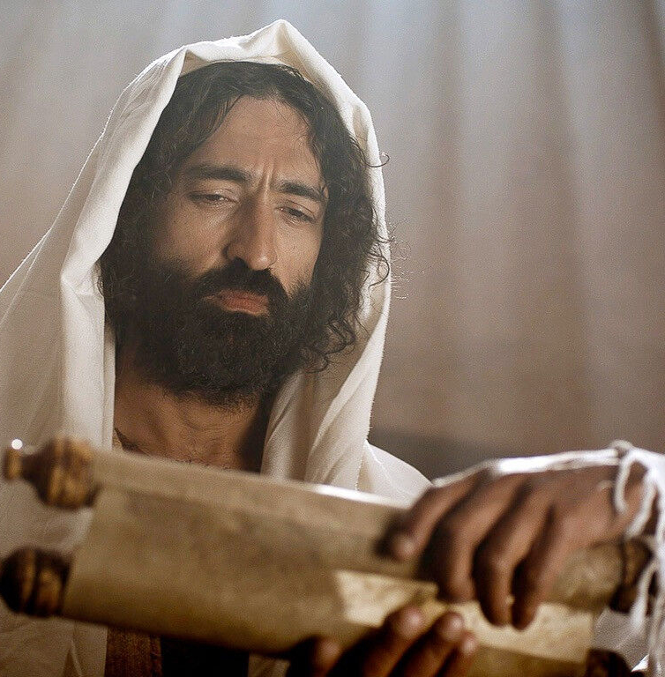
Acknowledge the sovereignty of God.
God is the Creator of the heavens and the earth. He is the Sovereign Ruler over all creation. It is vital that we acknowledge Him as our final Authority and the One whom we will obey. If our primary allegiance is not to God, we will never understand the true meaning of obedience. „Know ye that the Lord he is God: it is he that hath made us, and not we ourselves ...” (Psalm 100:3).

Receive God’s remedy for disobedience.
At Christ’s crucifixion, Satan held a „legal document.” On it was written the acts of disobedience of every person in the world, which he would use to destroy them in hell. Jesus snatched the document out of Satan’s hand, nailed it to the cross on which He hung, and blotted out the handwriting with His own blood. By doing this, He provided redemption for every person who would confess Jesus as his or her Lord and Savior. (Read Colossians 2:14-15 and John 3:16.)

Present your body as a “living sacrifice.”
After we are redeemed by the blood of Christ, we are instructed in Romans 12:1-2 to present our bodies to God as a living sacrifice. We are not to be conformed to this world, but transformed by the renewing of our minds, that we might experience God’s perfect will for our lives. By understanding that our bodies belong to God and our purpose in life is to glorify Him, we have the foundation for wise obedience.

Give God control of your money.
Whoever controls our money controls us, because almost every decision we make involves finances. By dedicating our money to God, we will be forced to check with Him before spending any of it. He will give us wisdom and direction through the principles of His Word. Obedience in the area of money begins with weekly tithes and offerings. (See Malachi 3:10-11; Matthew 6:19-21; and the entire book of Proverbs.)


2. How to Be Obedient to Your Parents

Honor your parents.
When you obey your parents, you demonstrate to them and to others that you honor them as your God-given authorities. In the same way, any disobedience to your parents is a public demonstration of dishonor. The first commandment with a promise is “. . . Obey your parents in the Lord: for this is right. Honour thy father and mother;which is the first commandment with promise; That it may be well with thee, and thou mayest live long on the earth” (Ephesians 6:1-3).

Obey your parents instantly.
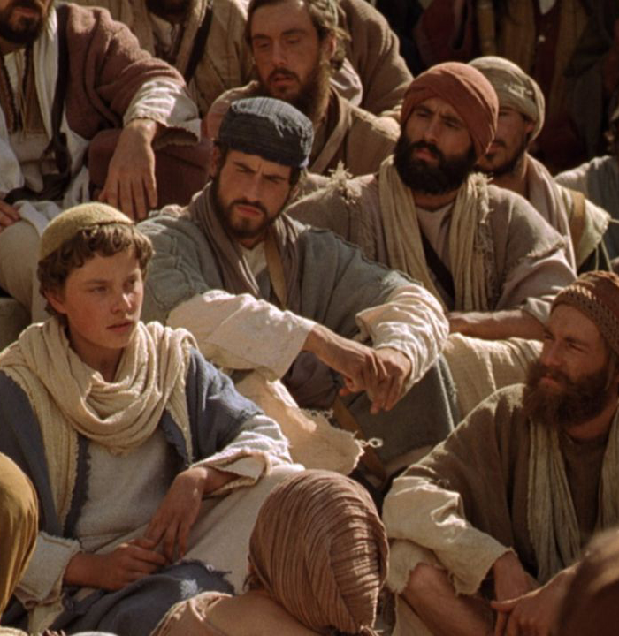
Delayed obedience is a form of rebellion; thus, any hesitation to carry out instructions causes parents to react. You may have intentions to obey your parents; however, if you do -not quickly respond, it is easy to become distracted by other people or activities. You may then be offended if your parents accuse you of being disobedient. However, they would be correct, because an attitude of obedience involves acting quickly.

Do each task without murmuring.
True obedience is doing what you are told, when you are told to do it, in the way you are told to do it, and cheerfully. Murmuring or complaining about having to do a task grieves the Lord, dishonors your parents, and robs you of the reward that comes with obedience. God tells us to „do all things without murmurings and disputings: That ye may be blameless and harmless, the sons of God, without rebuke, in the midst of a crooked and perverse nation, among whom ye shine as lights in the world” (Philippians 2:14-15).

Seek instruction, teaching, and guidance.
The ability to obey is based on knowing what to do (instruction), knowing how to do it (teaching), and knowing that you are doing it correctly (guidance). These three vital factors of training are emphasized in Psalm 32:8: „I will instruct thee and teach thee in the way which thou shall go: I will guide thee with mine eye.” Parents often expect obedience by giving one or two of these factors. Ask questions when you need more information.

Acknowledge commands, and report results.

There is something refreshing about a son or daughter who listens to a command, cheerfully and respectfully says, „Yes, sir,” or „Yes, ma’am,” and immediately sets out to do it. If addressing your parents as „sir” or „ma’am” seems too formal to your parents, you can still respond by saying, „Yes, I’ll do it right now. Mom (or Dad).”
After completing the job, it is wise to report the results to your parents so they can assure you that it was done in the right way. Remember that cleanup is part of the job. (See Galatians 4:1-2.)

Know when and how to make wise appeals.
If your parents ever ask you to do something which is contrary to Scripture, violates the law or moral standards, or does not seem wise to you, it would be your responsibility respectfully and prayerfully to make an appeal. Base your appeal on the higher authority of God’s Law. (See Matthew 18:6.)

Pray for your parents daily.

God’s command to pray for all those in authority would certainly include parents. Pray that they will have wisdom to direct the family. Also pray that God will protect them and your family from damaging influences. (See I Timothy 2:1-5.)

3. How to Be Obedient to Your Conscience

Purpose to have a good conscience.
Daniel purposed in his heart that “...he would not defile himself with the portion of the king’s meat, nor with the wine which he drank ...” (Daniel 1:8). Therefore, when the temptation came to violate his conscience, he was able quickly to obey God’s Word. Once the conscience is violated by disobedience, it is weaker and less effective in giving further cautions.

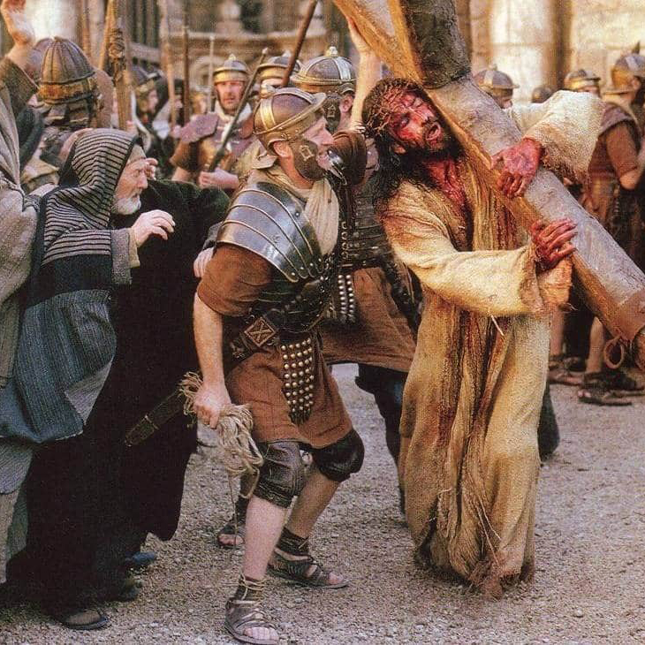
Restore a damaged conscience.
God has written His Law within our hearts. (See Romans 2:15.) When we are disobedient, we activate the conscience and grieve the Holy Spirit. If we continue to be disobedient, we sear the conscience and decrease its ability to warn us when we are doing evil. In order to restore the conscience, we must clear it of past offenses and then cleanse it by the daily reading of God’s Word. „Sanctify them through thy truth: thy word is truth” (John 17:17).

Clear up past offenses.
Write down the times that you have violated your conscience, and make a list of the people who have been hurt as a result of your wrong words, actions, or attitudes. Confess these offenses to God first, and then go to each person whom you have wronged. Briefly but clearly state how you have offended him, and ask him if he would forgive you.
If you do not know how to locate a person whom you have offended, work out the wording that you would use, and wait for God to bring him across your path. The importance of a good conscience is emphasized in Proverbs 28:13: „He that covereth his sins shall not prosper: but whoso confesseth and forsaketh them shall have mercy.”

4. How to Be Obedient to Your Church Elders

Give elders double honor.

We are to „let the elders that rule well he counted worthy of double honour, especially they who labour in the word and doctrine” (I Timothy 5:17). To give double honor to an elder involves rewarding him monetarily for his services. It also means giving him a higher degree of respect because he represents the authority of God’s Word and the delegated authority of the parents.
Because of the God-given responsibilities of elders to care for the spiritual welfare of each church member, you are to „Obey them that have the rule over you, and submit yourselves: for they watch for your souls, as they that must give account, that they may do it with Joy, and not with grief: for that is unprofitable for you” (Hebrews 13:17).

Confirm the teachings of your elders.
Check the teachings that you hear with what you read in the Bible. Make sure that verses are not taken out of context or used to substantiate wrong ideas. Even the Apostle Paul urged his listeners to compare what he taught them with Scripture.
„These were more noble than those in Thessalonica, in that they received the word with all readiness of mind, and searched the scriptures daily, whether those things were so” (Acts 17:11).
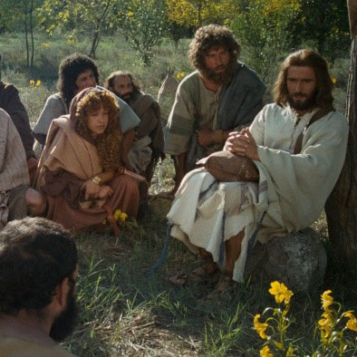
If an elder is teaching doctrines that are not Scriptural, follow the example of Aquila and Priscilla when they took Bible teacher Apollos aside and more perfectly explained the truths of Scripture to him.

Discuss the teachings of your elders.
God gives the final responsibility of instruction to parents, although they may delegate some teaching to others. (See Deuteronomy 6:4-7 and Galafians 4:1-2.) Those who teach the children ot others should view themselves as assistants to the children’s parents. If you are ever told not to tell your parents what you learn, tell your parents immediately. Such instruction is a clear violation of trust and a signal that you are being told things that are wrong by those who have improper motives.

Pray regularly for elders and instructors.

Anyone who has public responsibilities will be subjected to greater pressures and temptations. Therefore, he needs an extra measure of prayer. The Apostle Paul was certainly a strong leader, yet he pleaded for the prayers of those whom he taught, asking them to pray, “…that utterance may be given unto me, that I may open my mouth boldly, to make known the mystery of the gospel” (Ephesians 6:19). It is important to tell your elders and instructors how you are praying for them. You can do this through encouraging words, notes, or letters.

Provide financial support for your elders.
One of the clearest acts of obedience to God and to church elders is to give financially to their support. Even before the Law of Moses, God honored Abraham, Jacob, and others for giving 10 percent of their increase. (See Genesis 28:20-22 and Hebrews 7:2.)
In Malachi 3:10-11, God promises to rebuke the devourer of our resources if we honor Him in giving tithes and offerings. In the New Testament, Paul instructs us to give liberally to the church as God has prospered us. (See I Corinthians 9:1-14.) Tithes should be given on a weekly basis as an expression of worship and in order to learn the fear of the Lord.

5. How to Be Obedient to Civil Authorities


Accept civil authorities as God’s ministers.
God requires us to show honor to civil authorities as His ministers and to obey them because their authority comes from God. Three times in Romans 13, civil authorities are called „ministers of God”:
„For he is the minister of God to thee for good ... for he is the minister of God, a revenger… For this cause pay ye tribute also: for they are God’s ministers ...” (Romans 13:4-6). By accepting government officials as ministers of God, you will be better able to communicate to them the honor and respect which God intends for them.

Support civil authorities with your taxes.

God commands us to pay taxes. „... For this cause pay ye tribute also: for they are God’s ministers, attending continually upon this very thing. Render therefore to all their dues; tribute to whom tribute is due;custom to whom custom; fear to whom fear; honour to whom honour” (Romans 13:6-7). Jesus’ parents paid taxes at His birth and thereby fulfilled Scripture. Jesus paid taxes during His ministry, even after explaining to Peter that He should be exempt from taxes because He was the Son of God. (See Matthew 17:27.)

Help civil authorities carry out justice.
The ability of the government to function depends upon the cooperation of its citizens. Laws are ineffective if they are not supported by the people. Lawbreakers gain the upper hand if citizens do not do their part in cooperating with officials to bring them to justice. Ask local law officers what you can do to assist them to carry out their jobs. „They that forsake the law praise the wicked: but such as keep the law contend with them” (Proverbs 28:4).
Because God gives authority to rulers, they are ultimately responsible to Him for the decisions they make. Nations that build their laws on the principles of God’s Word will be wiser, wealthier, and healthier than other nations. You can help rulers base decisions on God’s Law by sending pertinent information to them and by demonstrating the truth of Christ in the way you live. Whatever you present should be neat, brief, and easy to read.


Pray for civil authorities and their families.
Public leaders are subjected to greater pressures and temptations than most people realize. Also, their families are in the public eye and are exposed to influences which can be damaging. Pray regularly that God would put a wall of protection around each leader and his family. Learn the names of your leaders’ family members, and if possible, find out what specific needs you can pray for. When appropriate, let them know how you are praying for them. Praise them for doing good.

Be an informed voter.
Voting is a responsibility of the citizens of a free nation. When a large segment of the population fails to vote, those with evil designs recognize that with a small minority, they can change the direction of a whole nation. When public leaders ask citizens to vote, it becomes a matter of obedience for them to follow this instruction.

Learn the laws and obey them.
It is important to learn every law that directly affects your life. If you drive a car, you should learn and obey all traffic laws. If you are in business, you must understand and comply with commercial regulations. If you are a home owner or a renter, you need to understand housing laws and building codes.


6. How to Be Obedient to Employers

Purpose to make your employer successful.
Obedience to your employer requires a „servant’s heart.” A servant’s heart is becoming excited about making others successful. True success is fulfilling God’s purposes. Our employment then is more than just doing a job; it is actually working for the Lord. From this perspective. God instructs all employees to put their whole heart into whatever they do as though they were doing it for the Lord and not simply for their employer. Your work will then be rewarded by the Lord, even though your employer may not adequately recognize or compensate you for benefiting him. (See Colossians 3:22-24.)

Clarify the jobs that are given to you.
Obedience is based on learning how your employer thinks. Before starting any job, make sure that you understand exactly what your employer expects of you. His expectations will involve more than just getting the job done. They will also include the way the job is carried out and the attitude in which it is done. Take notes on what is explained to you, and ask questions whenever necessary.


Do jobs in the order of their importance.
Some of the tasks that your employer assigns to you will not be as important to him as are other parts of your job. By doing what is important to him, you will be fulfilling his priorities. Most jobs will involve more work than you can accomplish during your working hours; therefore, some tasks will be left undone at the end of the day. If the things that are left undone are those things which are your employer’s priorities, your employer will perceive you as failing in obedience, even though you worked hard all day.

Do each job the way you were told to do it.
The very fact that your employer can hire you means that he has had a measure of success through trial and error. When he teaches you how to do a job, he is speaking from his experience in helping you avoid some of the mistakes that he has made. If you do the task your way and encounter the same problems that he encountered, you will be wasting time and resources and demonstrating disobedience.

Look for ways to be more efficient.
Assume that for every job given to you there is a more efficient way to do it; however, before changing the way you do a job, make a clear, thorough presentation to your employer, showing him how you can save time and money while at the same time improving quality or safety. Before you present your ideas, purpose to support fully your employer’s decision in accepting your idea, rejecting it, or not responding to it. Obedience is leaving the proposal in your employer’s hands and not continuing to pursue it on your own.

Work for quality control
The difference between success and failure is usually in attention to detail. People who investigate products or companies often base their decisions on little things which reveal the character of the company or the quality of the product. Quality control involves giving a person what he expects in quantity and quality. Your job is to ensure that a „just weight and measure” is maintained, because „Divers weights are an abomination unto the Lord; and a false balance is not good” (Proverbs 20:23).

Do cleanup as part of the job.
Obedience involves maintaining a neat work place, keeping tools and equipment in good condition, keeping accurate records, and having „a place for everything and everything in its place.”

XII. HOW TO BALANCE OBEDIENCE With Discernment

If you lack discernment, you are likely to obey the wrong person or carry out inappropriate instructions. In the area of obedience, discernment is knowing whom to obey and under what circumstances you would not obey.
A teenager asked his parents if he could play a practical joke on a neighbor, and the parents gave permission, with the stipulation that he clean up the mess the next day. As the teenager was carrying out his prank, the police arrested him for defacing property. In this situation neither the boy nor his parents had discernment, although the boy was trying to be obedient.
The Greek word for discernment means „to separate thoroughly; to decide between; to make a judicial estimation.” Discernment involves making a choice between right and wrong. „. . . A wise man’s heart discerneth both time and judgment” (Ecclesiastes 8:5).

1. With Enthusiasm
It is possible to obey an authority but grumble about it. Such an attitude communicates a disobedient spirit. When we carry out a Scriptural command such as paying tithes. God does not want us to do it grudgingly or out of necessity, but enthusiastically. (See II Corinthians 9:7.)
The word enthusiastic comes from the Greek words en Theos, which mean „of God.” Therefore, a believer who is obeying the Lord should be the most enthusiastic person there is.

2. With Love
The motivation for obedience must be genuine love. Love does not depend upon the attitude or rewards of the one being obeyed. Jesus Christ demonstrated obedience out of genuine love when He came into the world to die for our sins. One of the greatest hindrances to obedience is fear. Perfect love, however, casts out fear. „There is no fear in love; but perfect love casteth out fear: because fear hath torment. He that feareth is not made perfect in love” (I John 4:18).
Blessings to you, our dear friends!
We are happy to present the video, audio and paper materials that have been prepared by New Life for Churches. You have the privilege upon completion of your practical assignment to use this lecture with others.

Practical assignment
Completed
- Gather your family together and teach on obedience. Adjust the material to the age and attention span of your children. Interact with them, even at the teen level. Don’t make it a lecture! Write a short report on what you did, who was there and what interaction you had with different members.
Date:
Who:
How:
- Preach on obedience. Adapt to the audience. Use many illustrations. Write a brief report below
Date:
Where:
Who:
What was the response:

